**Stored procedure contains following queries:**

1. **Total sales in a month (Use only order table).**
2. **Profit/loss in a month (Use product (to account for purchasing costs), expenditure as well as order tables).**
3. **Highest selling product of the month (By highest sold quantity)**
4. **Lowest selling product of the month (By lowest sold quantity)**

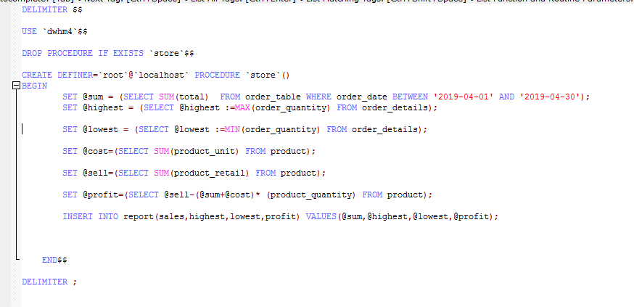

Call

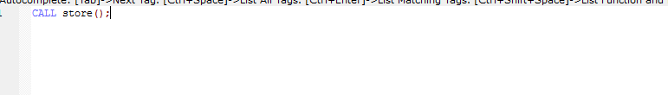

Result

